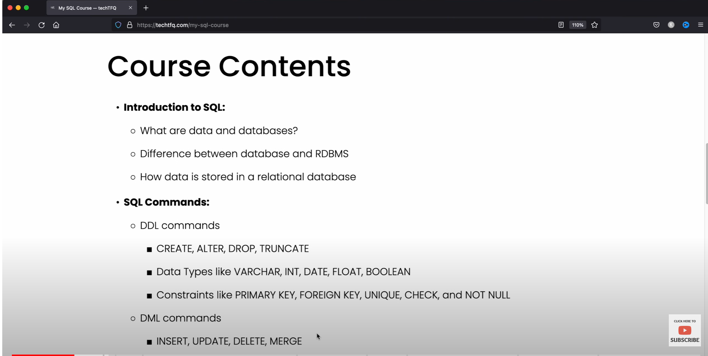

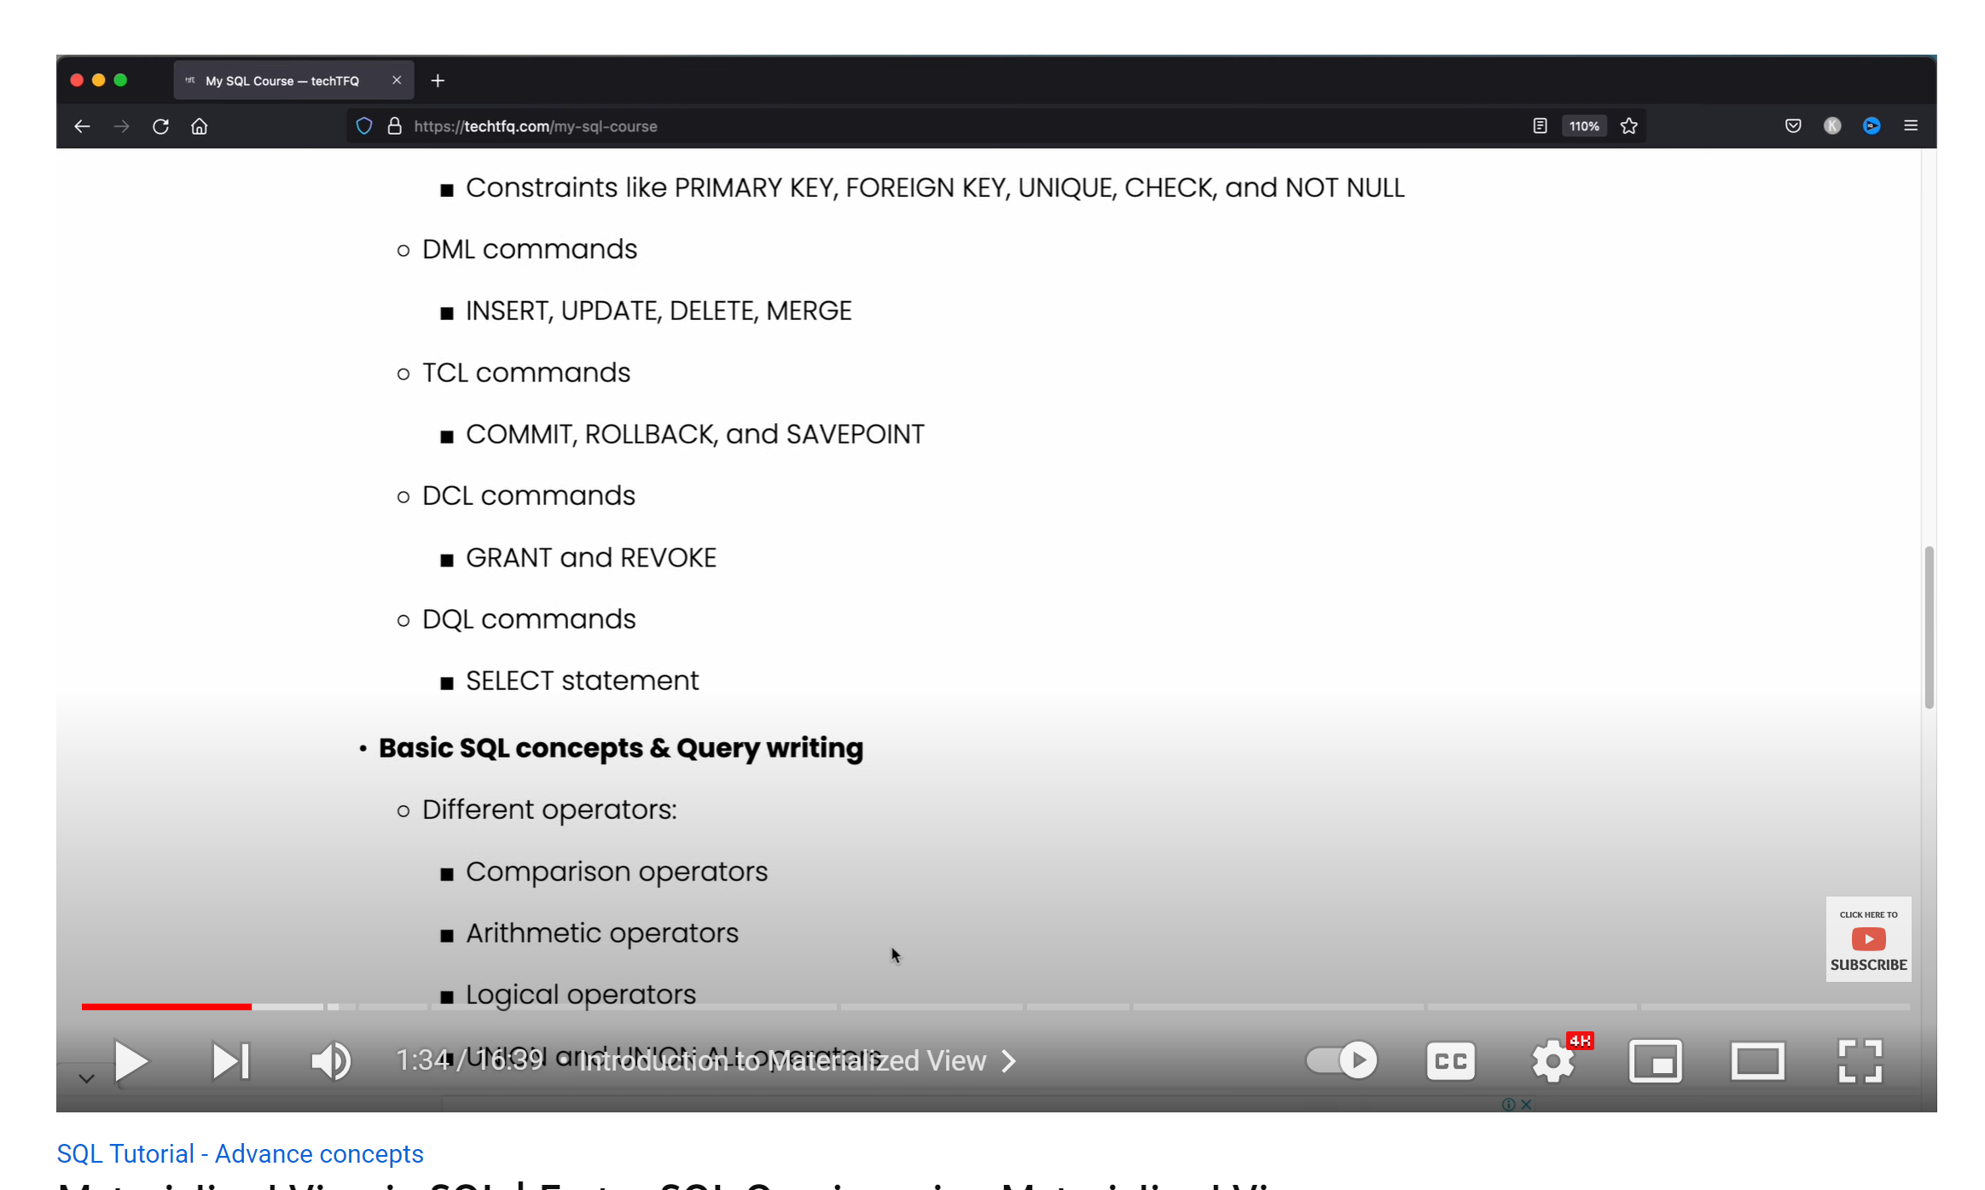

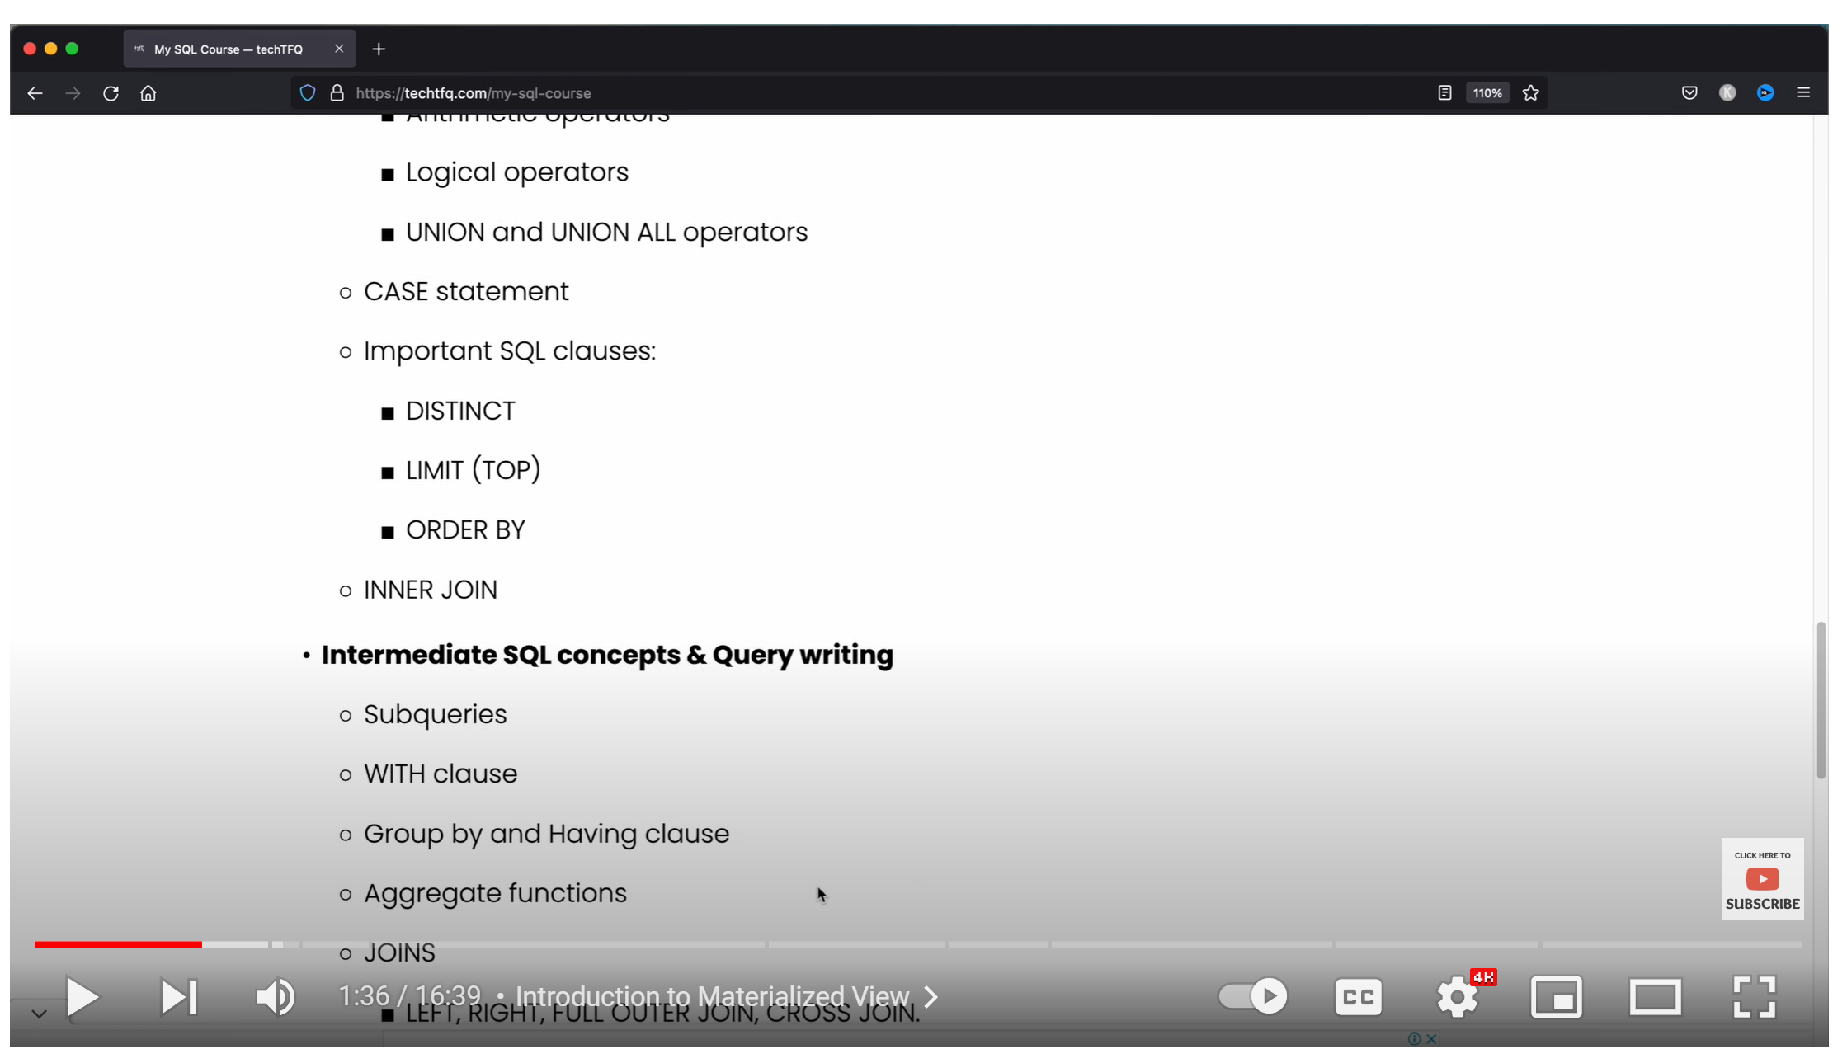

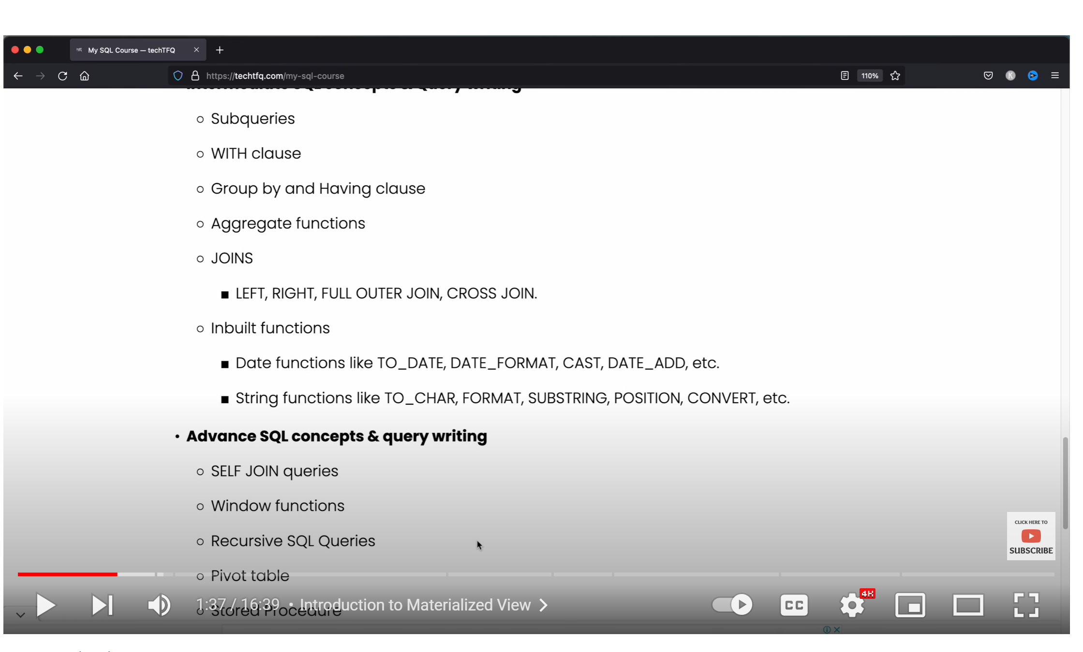

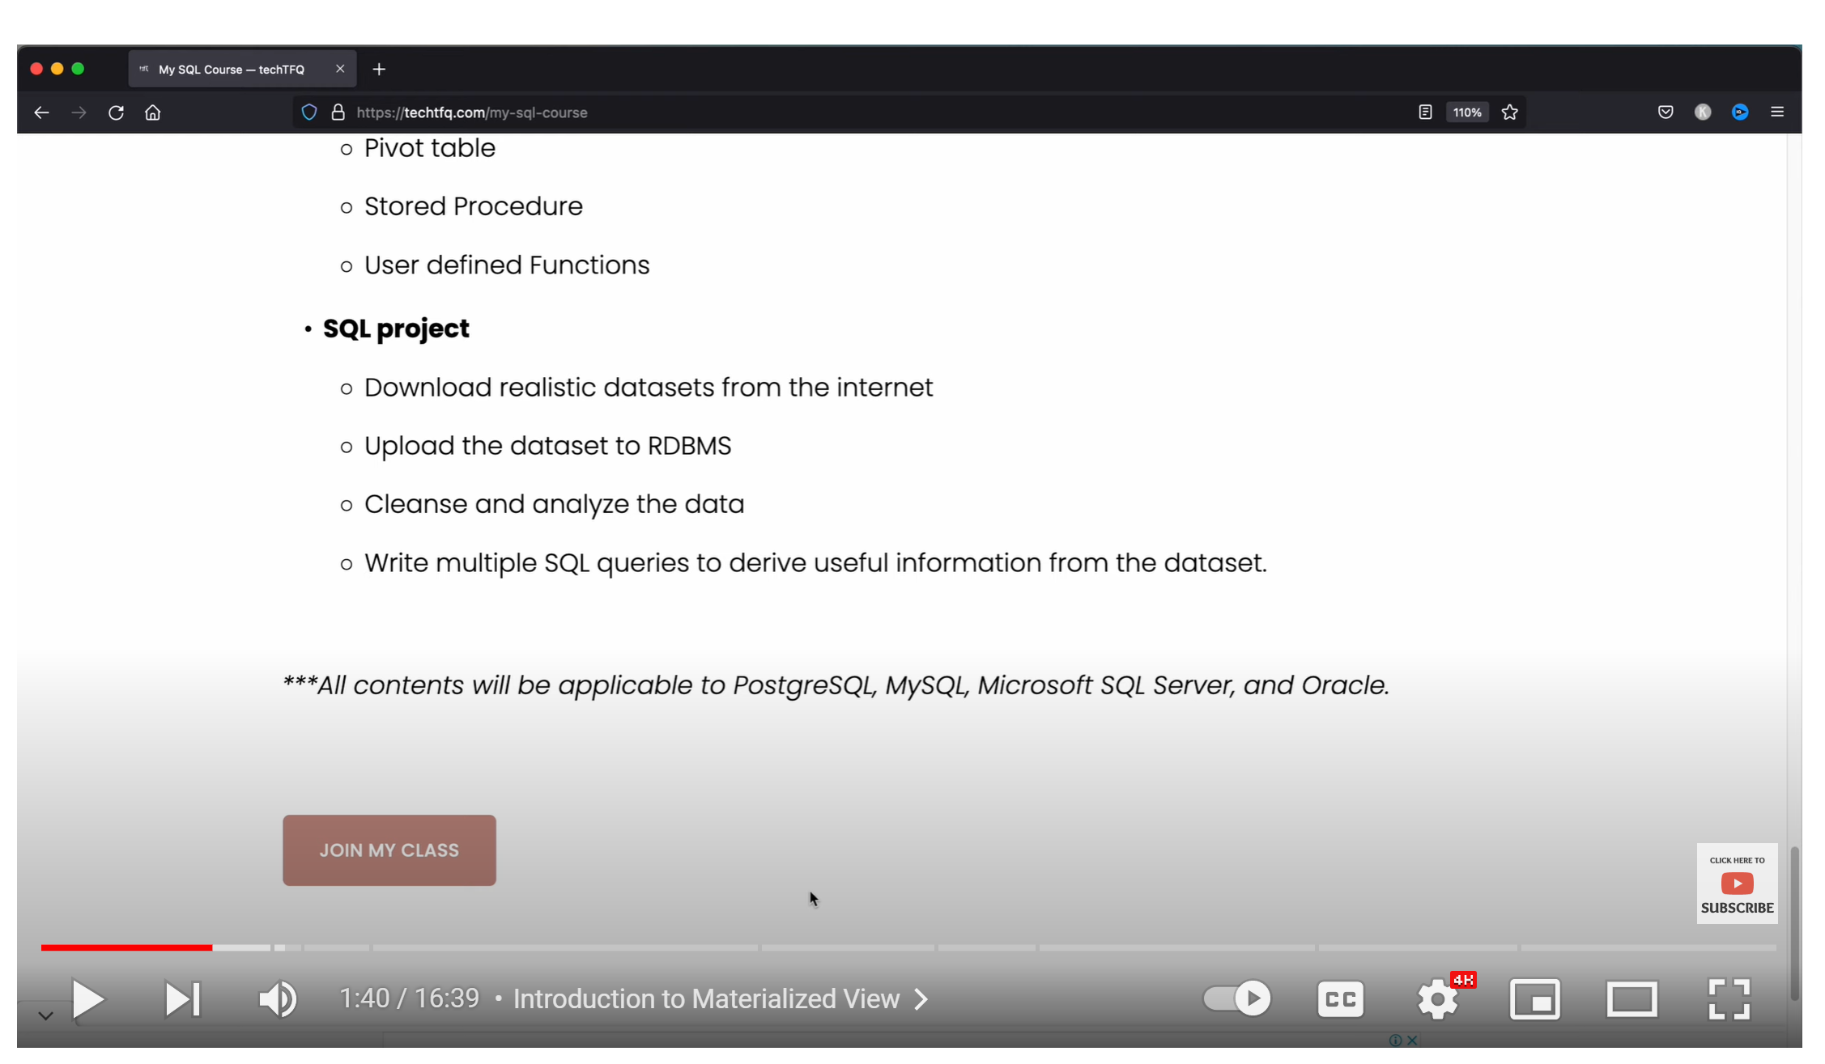

MYSQL is an open source relational database management system.

MYSQL is a Microsoft developed RDMS.

SQL is a query programming language that manages RDBMS. MySQL is a relational database management system that uses SQL. SQL is primarily used to query and operate database systems. MySQL allows you to handle, store, modify and delete data and store data in an organized way.

Learning the basics of SQL will likely serve you well with whichever database you or your company uses.

MYSQL:

MySQL provides various storage engines for its tables: MyISAM, InnoDB, Merge, MEMORY (HEAP), ARCHIVE, CSV and FEDERATED.

For example, the CSV engine will store the data in a CSV file format. This could be used to migrate data into alternative, non-SQL applications such as spreadsheet software.

In a nutshell, SQL is a language for querying databases and MySQL is an open source database product.

SQL is used for accessing, updating and maintaining data in a database and MySQL is an RDBMS that allows users to keep the data that exists in a database organized.

SQL does not change (much), as it is a language. MySQL updates frequently as it is a piece of software.

In layman’s terms, SQL could be seen as a bank teller and MySQL could be seen as the bank. You need the bank teller (SQL) to communicate with the bank (MySQL) and you need the bank to manage the money (the data). They work in tandem but they are completely different.

**What is SQL Server?**

Like MySQL, SQL Server is a relational database management system. However, unlike MySQL, SQL Server is not open source. It is owned by Microsoft and there are several editions available, depending on the users’ needs and budget.

One of these editions is called SQL Server Express and is free to download and distribute. It comprises of a database specifically targeted for embedded and smaller-scale applications

A common question for those new to the field is “are SQL and SQL Server the same thing?”. In a word: no. The difference between the two is similar to the difference we laid out between SQL and MySQL. SQL is a language for querying databases and SQL Server is a system for managing relational databases.

In terms of MySQL vs SQL Server, there’s no right answer for every organization.

If you’re a startup company strapped for cash, you’re likely to opt for MySQL.

If you’re a large company looking to run high volumes of activity on a database, then you might lean towards SQL Server.

When it comes down to it each of the systems has their own advantages and disadvantages.

SQL:

In the query above, we have just one clause: SELECT 2+3. We end it with a semicolon (;), which tells SQL the query has ended, similar to how a period (.) marks the end of a sentence.

earn

Learn

So far, we have used SQL to add numbers together. We can also use SQL to subtract, multiply, and divide numbers.

Here are a few examples:

* *Subtraction*: the query SELECT 1340 - 3; prints 1337.
* *Multiplication*: we use the * symbol to signify multiplication. The query SELECT 7 * 3; prints 21
* *Division*: we use the / symbol to signify division. The query SELECT 21 / 7; prints 3.

Here, we see a single query *and* renaming the results:



SELECT 1340 - 3 AS sub, 7 * 3 AS mult, 21 / 7 AS div, 5 * (2 + 3) AS sum_mult;

Copy

| **sub** | **mult** | **div** | **sum_mult** |
| --- | --- | --- | --- |
| 1337 | 21 | 3 | 25 |

Notice that we use the AS directly after each query to rename results. Also note the use of parentheses in 5 * (2 + 3). SQL follows the usual order of operations we know from mathematics:

1. Operations in between parentheses are executed first
2. Secondly come multiplication and division (in no particular order)
3. Then come addition and subtraction (in no particular order)

This screen's exercise is a culmination of all that you have learned so far. Don't feel discouraged if it takes you longer to complete than the previous exercises.

By themselves, these words aren't clauses. Despite this, to facilitate communication, it's common to call SELECT and FROM clauses.

The first thing SQL does when it runs a query is determine what data it will be looking at. Thus, it executes FROM first.

From the clauses we learned thus far, the second in the order of execution is SELECT. So, after determining the table we're getting data from, SQL will choose the selected columns

Finally, SQL limits the results with LIMIT.

DISTINCT : gives the unique values on a column

You may have noticed that SELECT, FROM, and LIMIT are usually highlighted. This happens in part because they are reserved words. Column and table names are not reserved words.

Even though it's not necessary for reserved words to be uppercase, we recommend you capitalize all letters for consistency. (We'll go into more detail soon.)

Sequence to learn SQL:

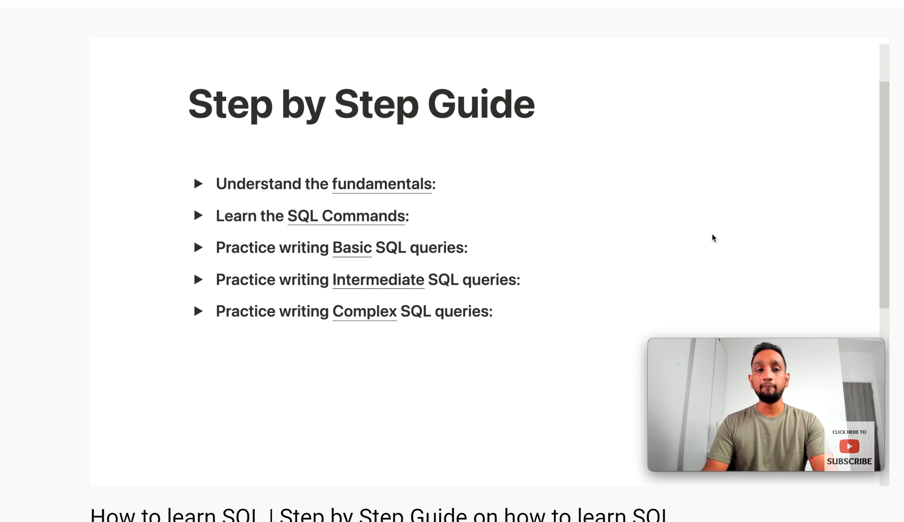

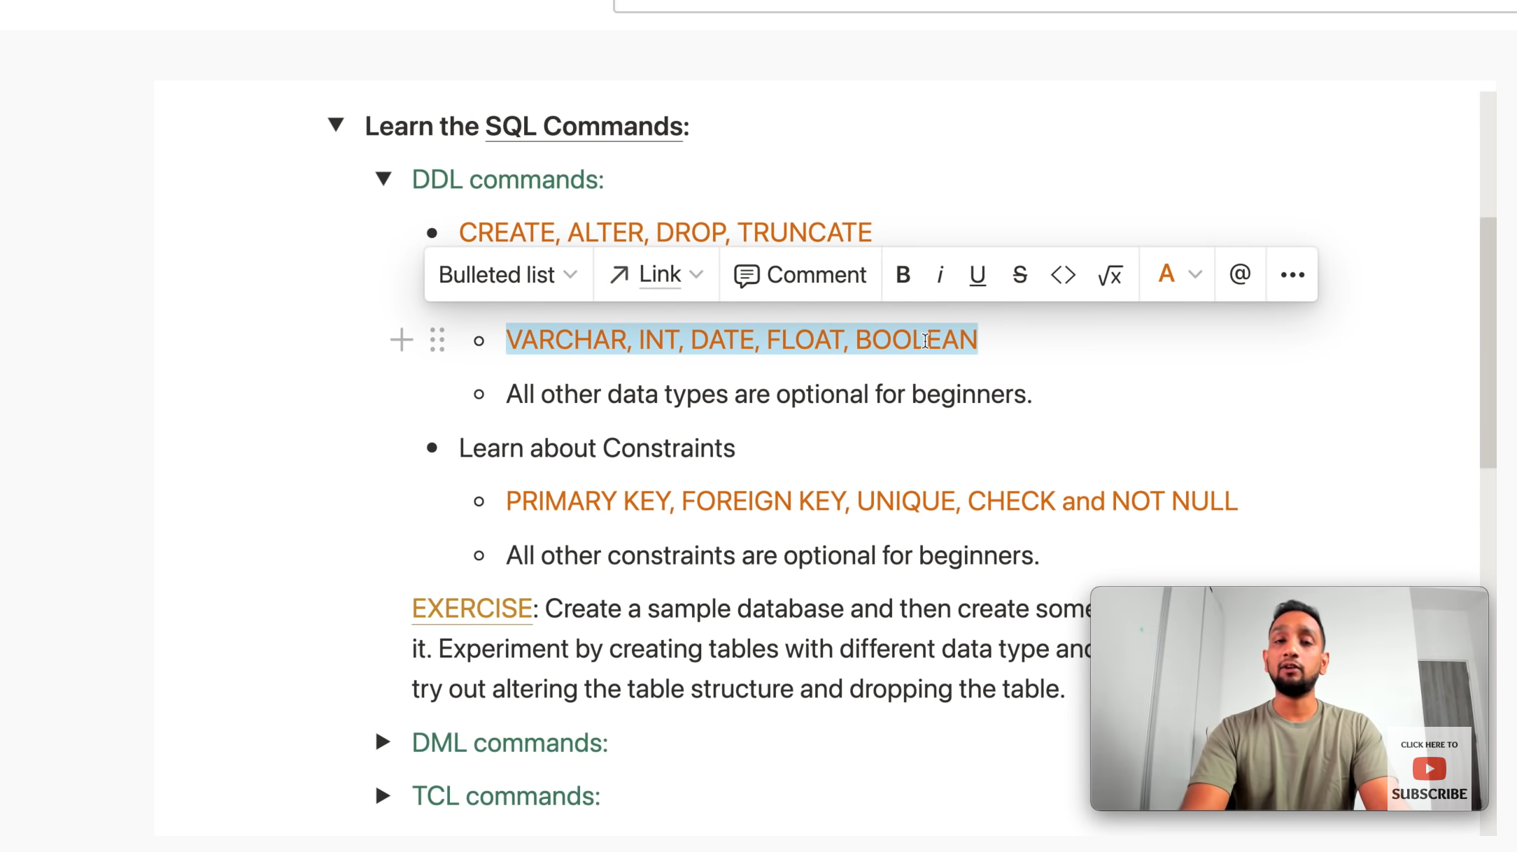

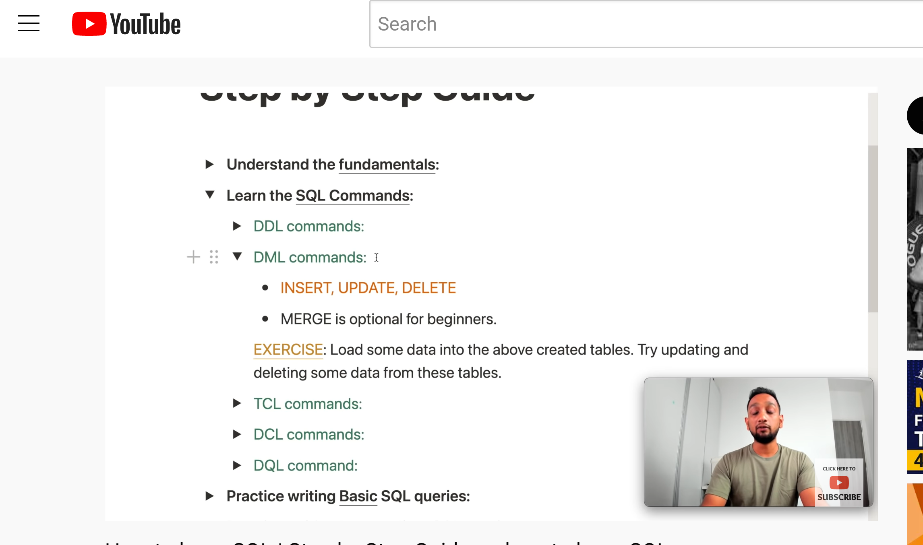

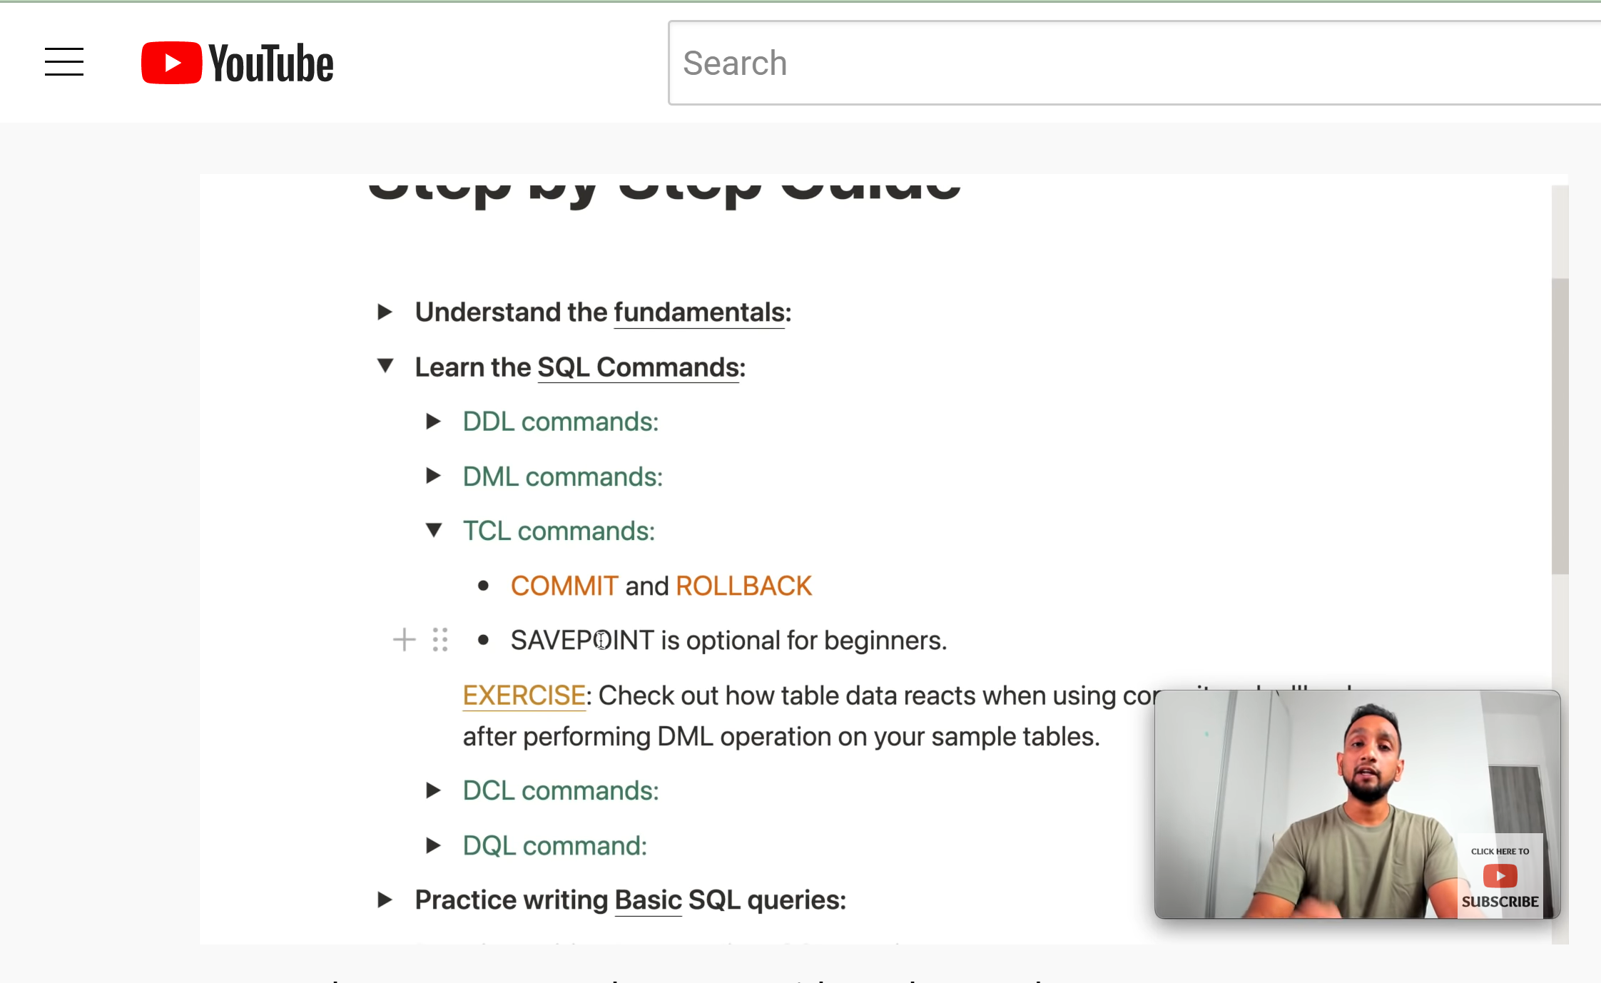

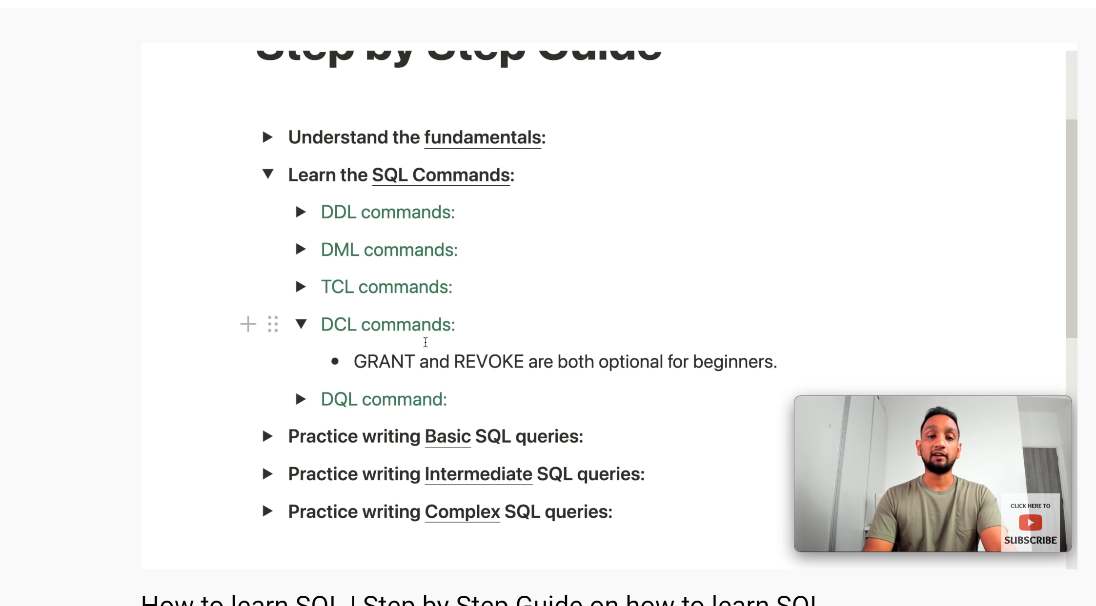

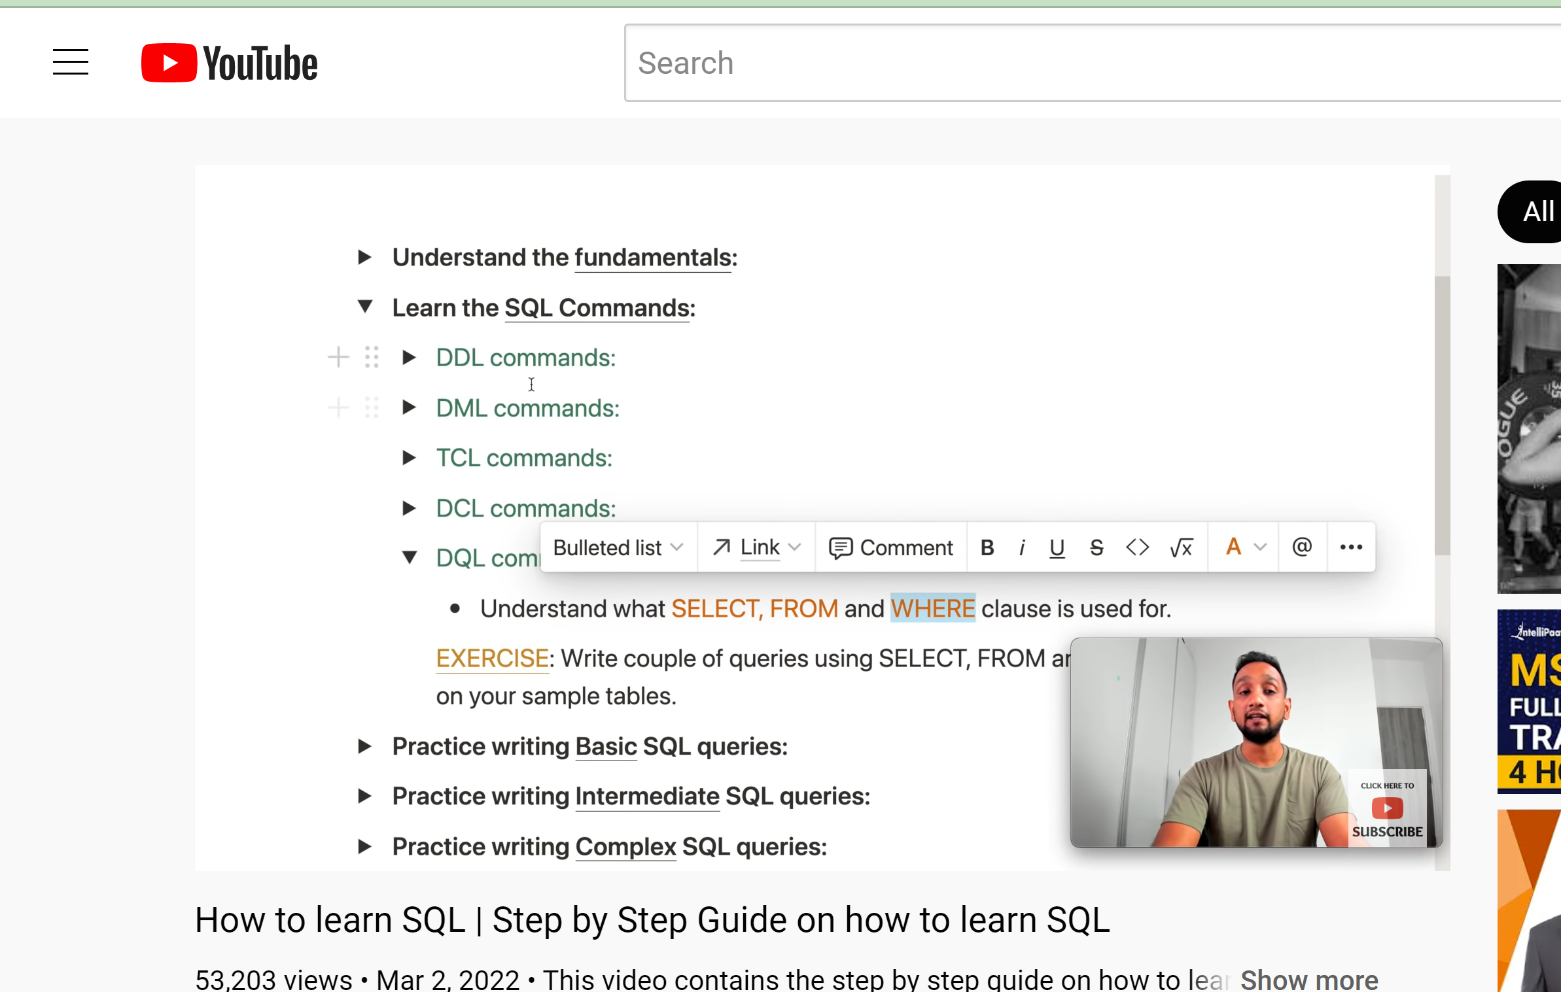

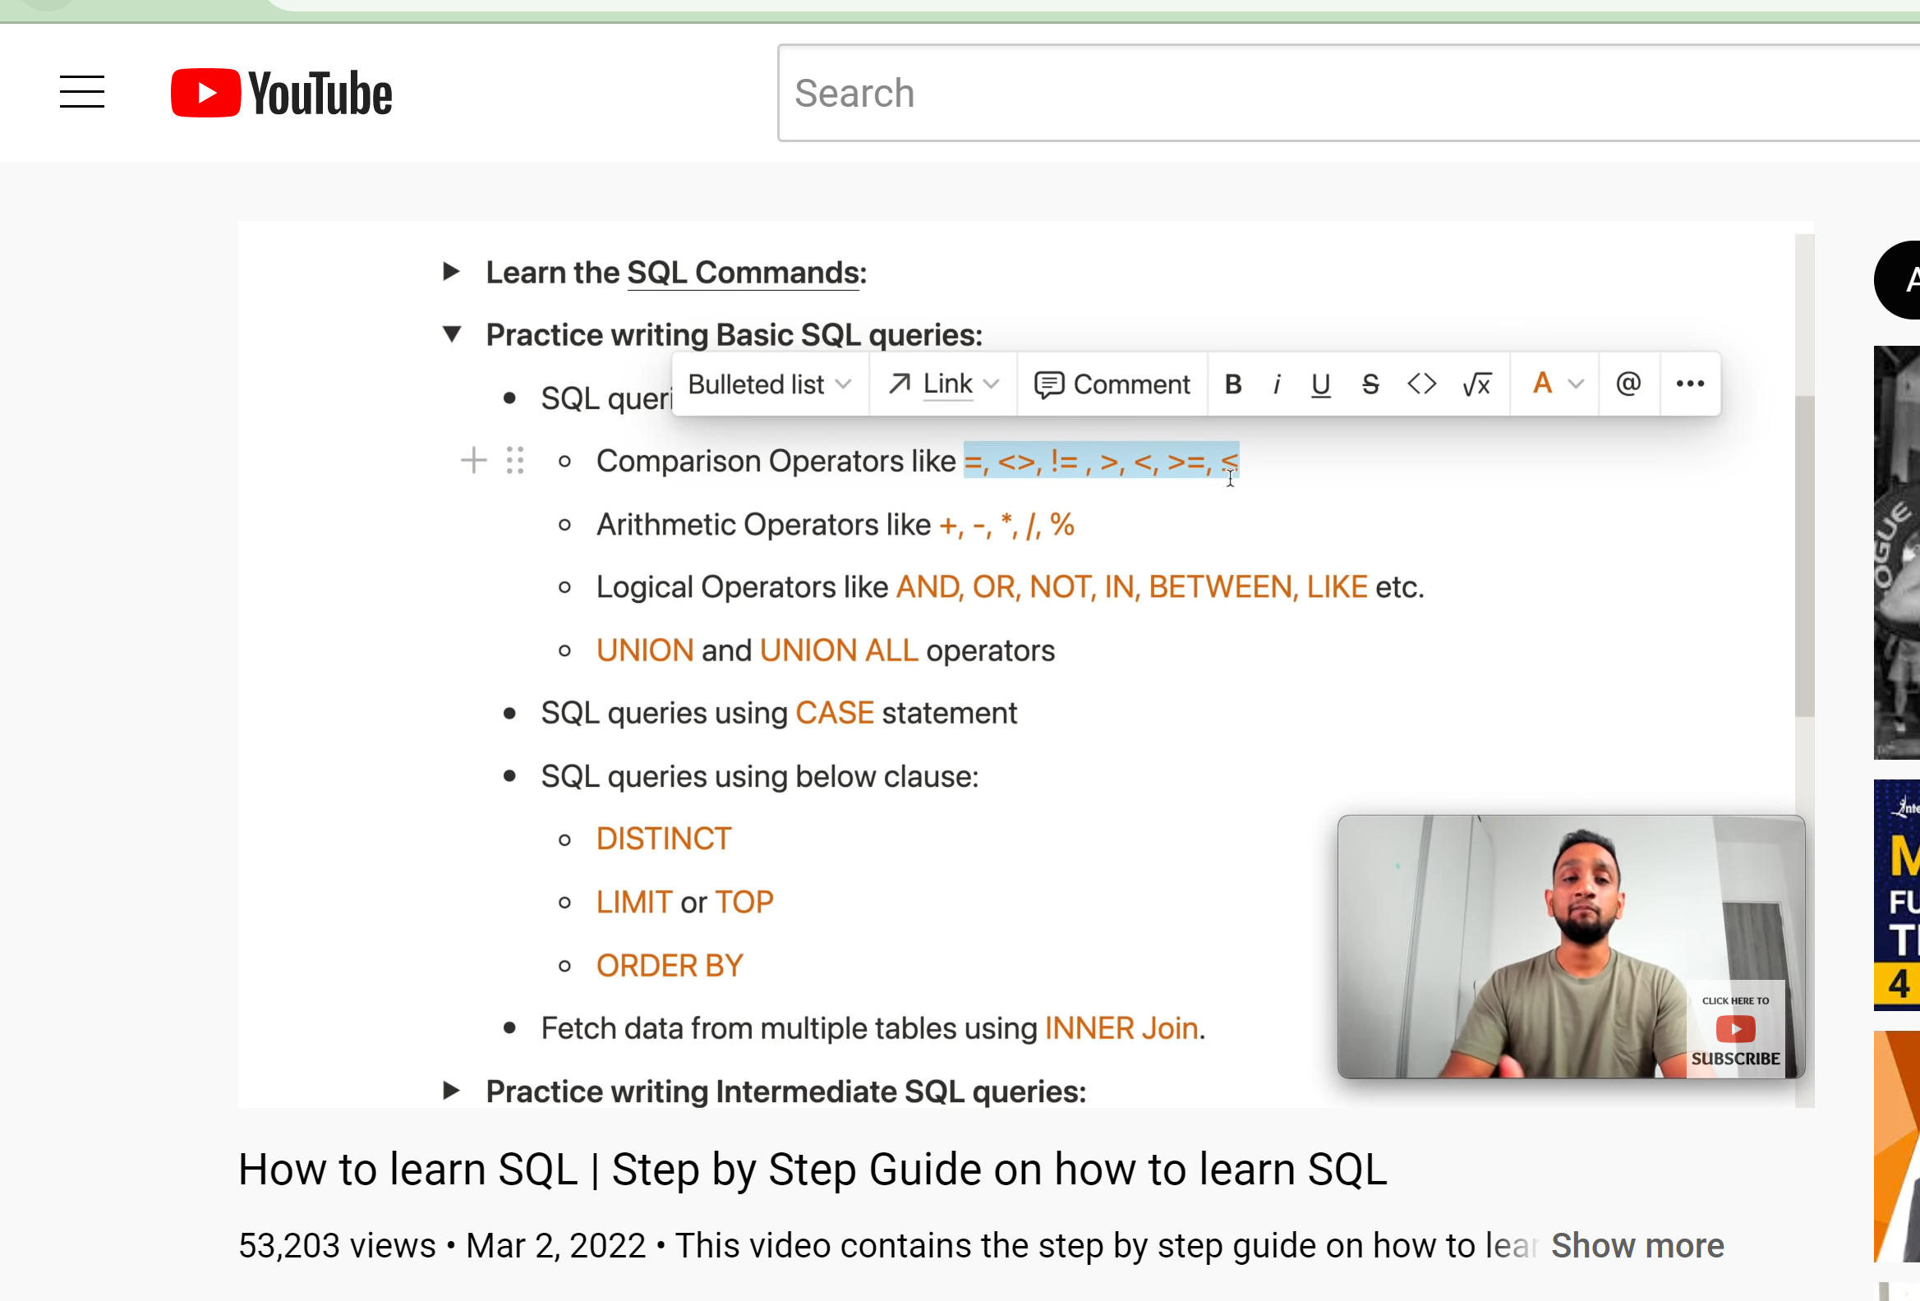

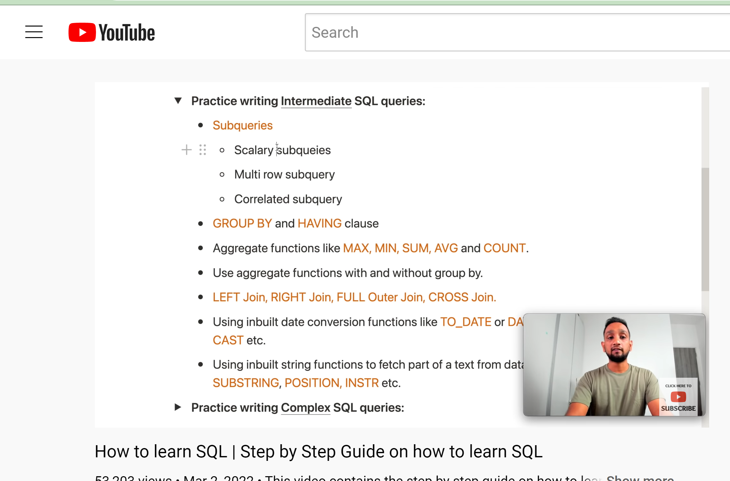

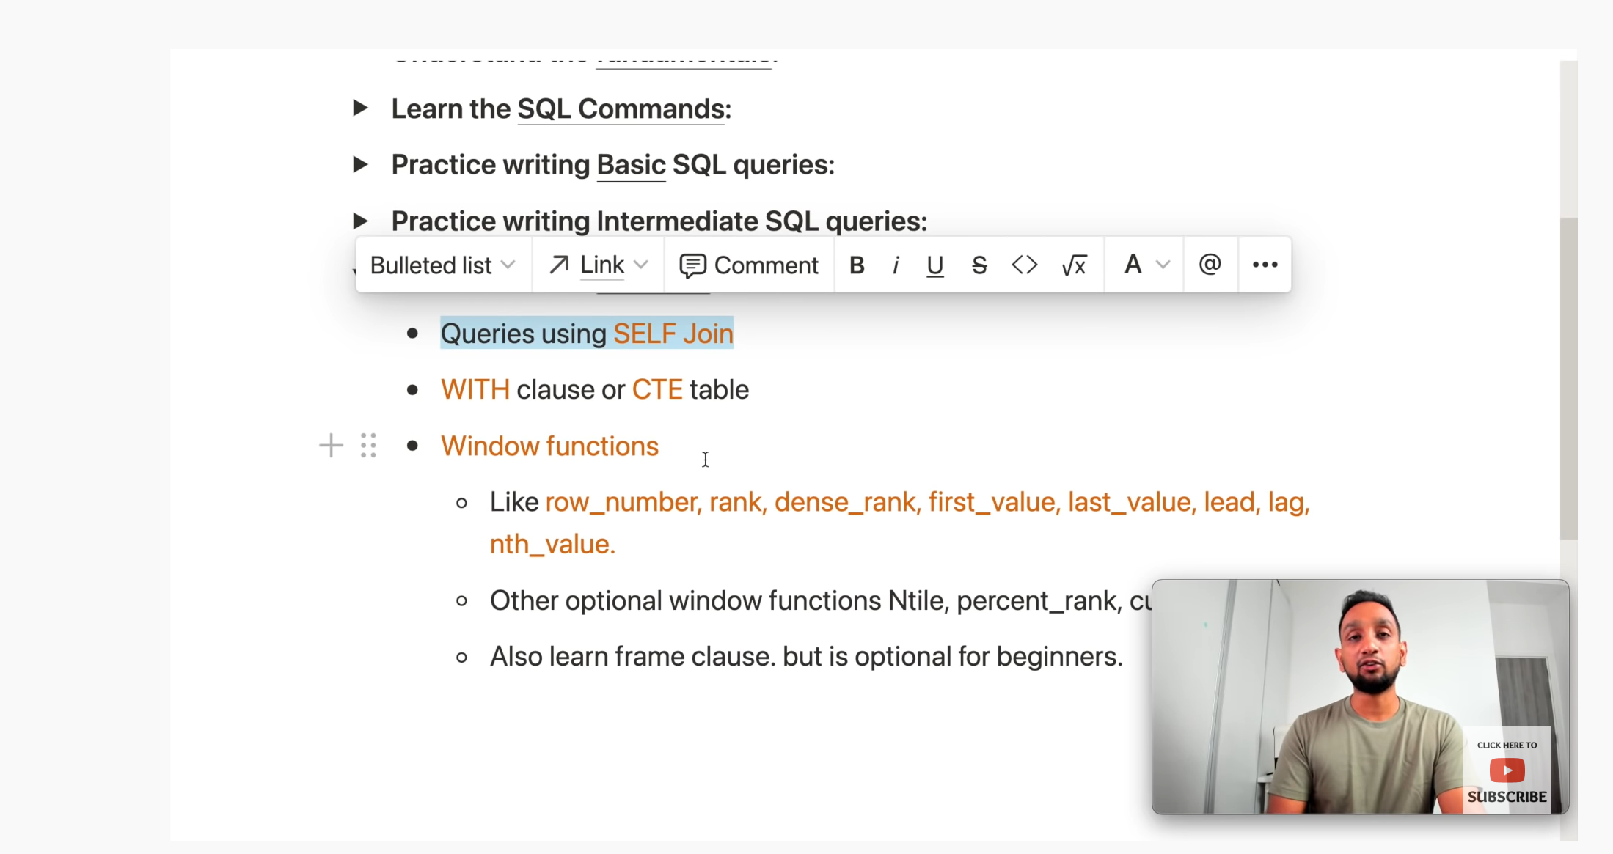

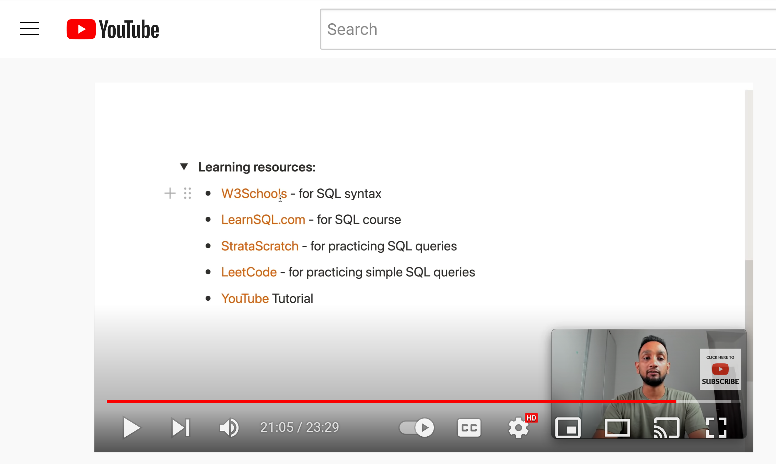

SQL blog link :

<https://techtfq.com/blog/step-by-step-guide-on-how-to-learn-sql>

<https://www.youtube.com/watch?v=eXJGjbDo5KY>

* SELECT - extracts data from a database
* UPDATE - updates data in a database
* DELETE - deletes data from a database
* INSERT INTO - inserts new data into a database
* CREATE DATABASE - creates a new database
* ALTER DATABASE - modifies a database
* CREATE TABLE - creates a new table
* ALTER TABLE - modifies a table
* DROP TABLE - deletes a table
* CREATE INDEX - creates an index (search key)
* DROP INDEX - deletes an index

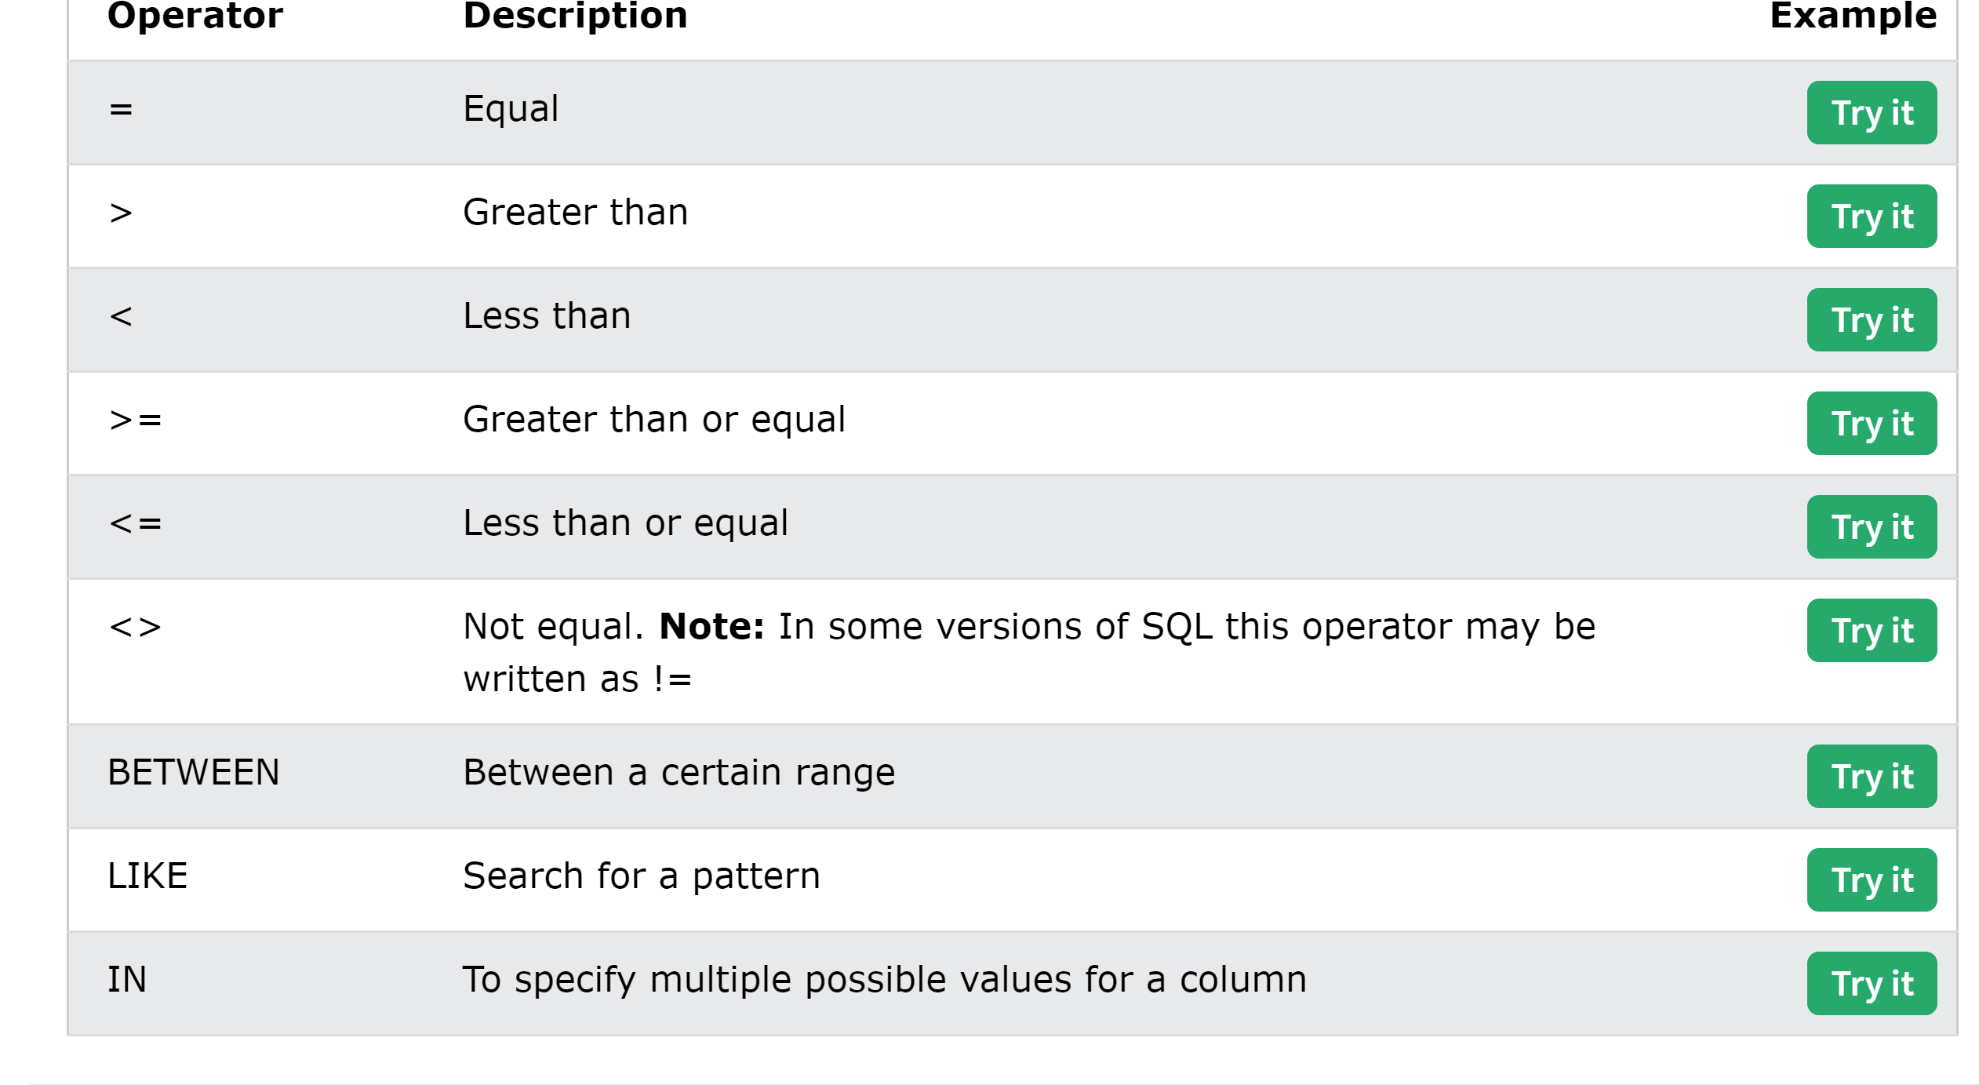

You can use WHERE clause with NOT :

SELECT * FROM Customers

WHERE NOT Country='Germany';

These following two statements gives the same values

SELECT * FROM Customers

WHERE Country='Germany' AND City IN ('Berlin','München');

SELECT * FROM Customers

WHERE Country='Germany' AND (City='Berlin' OR City='München');

The ORDER BY keyword is used to sort the result-set in ascending or descending order.

The ORDER BY keyword sorts the records in ascending order by default. To sort the records in descending order, use the DESC keyword.

### **ORDER BY Syntax**

SELECT column1, column2, ...  
FROM table_name  
ORDER BY column1, column2, ... ASC|DESC;

SELECT * FROM Customers

ORDER BY Country ASC, CustomerName DESC;

Insert query:

INSERT INTO Customers (CustomerName, ContactName,Address,City,PostalCode,Country)

VALUES ('Cardinal','Tom B. Erichsen', 'Skagen 21', 'Stavanger','4006','Norway',);

## What is a NULL Value?

A field with a NULL value is a field with no value.

If a field in a table is optional, it is possible to insert a new record or update a record without adding a value to this field. Then, the field will be saved with a NULL value.

**Note:** A NULL value is different from a zero value or a field that contains spaces. A field with a NULL value is one that has been left blank during record creation!

It is not possible to test for NULL values with comparison operators, such as =, <, or <>.

We will have to use the IS NULL and IS NOT NULL operators instead.

SELECT column_names

FROM table_name

WHERE column_name is NULL;

SELECT column_namesFROM table_name  
WHERE column_name IS NOT NULL;

UPDATE Customers

SET ContactName = ‘Alfred Schmdit’, City = ‘Frankfurt’

WHERE CustomerID = 1;

UPDATE Customers

SET ContactName = ‘Juan’

WHERE Country = ‘Mexico’;

DELETE FROM table_name WHERE condition;

DELETE FROM Customers WHERE CustomerName = ‘Kalyani’;

It is possible to delete all rows in a table without deleting the table.

This means that table structure , attributes and indexes will be intact.

DELETE FROM table_name;

DELETE from Customers;

SELECT * FROM Customers LIMIT 3;

SELECT * FROM Customers FETCH FIRST 3 ROWS ONLY;

SELECT * FROM Customers  
FETCH FIRST 50 PERCENT ROWS ONLY;

SELECT * FROM Customers

WHERE Country = ‘Germany’

LIMIT 3;

Online analytical processing systems

* **Subject-oriented:** A data warehouse should contain information about a few well-defined subjects rather than the enterprise.
* **Integrated:** A data warehouse is an integrated repository of data. It contains information from various systems within an organisation.
* **Non-volatile:** The data values in a database cannot be changed without a valid reason.
* **Time-variant:** A data warehouse contains historical data for analysis.

So, essentially, facts are the numerical data in a data warehouse and dimensions are the metadata (that is, data explaining some other data) attached to the fact variables. Both facts and dimensions are equally important for generating actionable insights from a data set.

#### Dimensional Modelling

What are the benefits of having dimension variables apart from facts? More than one option may be correct.



It helps with performing various types of analyses, such as sector-wise, country-wise or funding-type-based analyses.

**✓ Correct**

**Feedback:**

Correct. This activity needs metadata along with the fact data.



It helps in summarising the fact variables by calculating their sum, average, range, etc.

**✕ Incorrect**

**Feedback:**

Incorrect. This can be done without additional dimension variables attached to the fact variables.



It helps with extracting specific, useful information, such as the total investment made in the Automobile sector in India between 2014 and 2015.

**✓ Correct**

**Feedback:**

Correct. This activity needs metadata along with the fact data.

A schema is anoutline of the entire data warehouse. It shows how different data sets are connected and how the different attributes of each data set are used for the data warehouse.

Transactional Databases are the databases which carries out day-day business transactions.

Transactional database covers day-day business related transactions , while dataware house helps for data analysis and decision making used by CEOS,CXOS for decision making etc

**Question 1/3**

Mandatory

#### OLAP vs OLTP

Which of the following statement(s) is/are true? More than one option may be correct.



In OLAP systems, data is taken from a single data source.



Compared with OLTP, OLAP systems use complex queries to perform tasks, because in OLAP, we perform analysis on various tables and it needs complex queries.

**✓ Correct**

**Feedback:**

OLTP systems use simple queries for adding, deleting, updating and retrieving data. Relatively complex queries are used in OLAP involving aggregations.



OLAP systems use ETL.

**✓ Correct**

**Feedback:**

OLAP systems need data from different data sources. Before all the data is collected, we need to ensure that the interpretation of the data from different data sources is the same and that it is loaded into the data warehouse structure.



Schemas are an essential part of creating OLAP systems.

**✓ Correct**

**Feedback:**

Schema diagrams are essential for creating a data warehouse design. They indicate how the fact and dimension tables will be connected.

**Your answer is Correct.**

**Attempt 1 of 2**

Continue

In this way, you have understood about OLTP and OLAP system. In the next segment, you will learn about the SETL (Select, Extract, Transform and Load).

SETL:

**SETL: Select, Extract, Transform and Load**.

* Select: Identification of the data that you want to analyse
* Extract: Connecting to the particular data source and pulling out the data
* Transform: Modifying the extracted data to standardise it
* Load: Pushing the data into the data warehouse

This process includes the typical operations that are involved in selecting the required data, extracting data from multiple sources, operating on the data so that data from multiple sources is compatible, and loading this data into a data warehouse for analytical purposes.

constraints are the rules that are used in MySQL to restrict the values that can be stored in the columns of a database. This ensures data integrity, which is nothing but the accuracy and consistency of the data stored in the database.

#### Primary Keys

A primary key constraint always enforces both the UNIQUE and NOT NULL constraints.



True

**✓ Correct**

**Feedback:**

Since a column that is a primary key cannot contain duplicate and null values, it enforces both the UNIQUE and NOT NULL constraints automatically.

The second type of constraints is called referential constraints. These are used to restrict the values that are taken by a column in one table based on the values that exist in another table.

CustomerID is a foreign key in the 'Orders' table because it is used to reference the 'Customers' table. You can easily determine which customer placed a particular order and find out all the details of that customer by looking up the corresponding customer id in the 'Customers' table

a referential constraint is a rule between two tables. According to this rule, the value that appears as a foreign key in a table is valid only if it also appears as a primary key in the table to which it refers.

#### An Example of a Referential Constraint

Which of the following scenarios would require using a referential constraint?



All phone numbers should contain the area code.



Certain fields are mandatory to fill (such as phone number) before the record is accepted in a database.



Information on a customer must be known before anything can be sold to that customer, so that you can refer to other fields to get the information of the customers.

**✓ Correct**

**Feedback:**

This would constitute a foreign key constraint, which is a referential constraint. This is because customer details are required before a particular product can be associated with the customer who placed the order for that product.



When entering the card number for payment, the user must input a 16-digit number.

1. A primary key identifies each row in a table uniquely, whereas a foreign key uniquely identifies a row in the same table or in another table.

2. Only one primary key is allowed in a table, whereas it can have multiple foreign keys.

So, as you learnt in the video, semantic constraints impose additional restrictions on the values in a column. For example, all the mobile numbers in India start with '+91', followed by 10 digits. Using a semantic constraint for this requirement ensures that we do not get incorrect data for any row. For example, a row with a phone number +91987654321 would not be allowed to enter the database as it has only 9 digits after the country code.

#### Semantic Constraints

Consider a column containing the blood groups of various blood donors. Which of the following options is an example of a semantic constraint in this case? More than one option may be correct.



A blood group can contain one of the following values: A, B, AB and O.

**✓ Correct**

**Feedback:**

This is a semantic constraint as it ensures that only particular values can belong to the 'Blood Group' column.



A blood group can contain only characters.

**✓ Correct**

**Feedback:**

This is a semantic constraint as it ensures that only particular values can belong to the 'Blood Group' column.

the market star schema consists of five tables: 1 central fact table and 4 dimension tables, which describe the fact table. This structure of one fact table with multiple dimension tables makes data analysis easier because it reduces the number of joins required for querying data.

* What a data warehouse is
* The differences between a data warehouse and a transactional database
* OLAP (Online Analytical Processing) systems are Subject-oriented, Integrated, Non-volatile and Time-variant
* A data warehouse provides an integrated view of the entire organisation and the data is organised for carrying out analysis efficiently
* Facts and dimensions and how to arrange them in order to design a data warehouse
* Dimension tables act as metadata, which is data about data, and enhance the facts table to enhance the insights from the data
* What a star schema is
* The advantages of having a star schema in a database
* The SETL process: Select, Extract, Transform and Load
* The different types of constraints: Entity, Referential and Semantic constraints
* ERDs and their constituents

SUMMARY OF TOPICS :

WINDOWS FUNCTION

CTES

RECURSIVE QUERIES

JOINS

Windows Functions / My SQL Functions SQL:

Fetch top 3 employees from each department from the employee table who earns the max salary .

Display min and max salaries from each department corresponding to each employee record.

1.Suppose we want to obtain a list of employee names, salaries, and the top salary in their departments.

SELECT employee_name , salary, dept, max(salary) FROM employee

GROUP BY dept;

But here we need list of employee names which are individual records so this can be possible only through windows function since using GROUP BY clause groups the data falling up the individual records so using above query, we can’t get the individual records of employee name w.r.t to dept we will get only employee name who has max(salary) in that dept so we will go for window functions.

**SELECT employee_name , salary, dept, max(salary) OVER (PARTITION BY dept) as top salary FROM employee;**

Explanation: Here we used max as an analytic function instead of aggregation function by providing over keyword and if we don’t pass anything under OVER SQL will create one window and max salary is applied for all the rows in table so in this context it will find the max salary from all the salary data and that value will be shown corresponding to each record in this result set.

So, we are passing PARTITION BY dept clause and what this does is its going to create a window for each distinct value in the dept column and apply the max(salary) function to each of those windows so we can get the max salary in each of the dept.

**ROW_NUMBER: ROW_NUMBER is a window function where one unique value will be assigned for each record here is the syntax below:**

Select e.*

Row_number() over (partition by dept_name) as rn

From employee e;

So if we are not passing partition by dept_name under over clause SQL will assign a unique identifier for all the records in the table for the single window created for all the values in the SQL Table.

So, we are passing partition by dept_name under over clause where SQL will create a window for each distinct value in dept and assigns the unique identifier for that particular dept.

E.g: Fetch the first two employees from each dept to join the company

Select * from

(Select e.*

Row_number() over (partition by dept_name order by emp_id) as rn

From employee e) X

Where X.rn < 3;

RANK: Fetch the top 3 employees in each department earning the maximum salary.

If we have duplicate values for a column in table sql assigns same rank to the those rows and skips the rank before assigning it to the next unique value in the row as below.

For e.g:

|  |  |  |  |
| --- | --- | --- | --- |
| Emp_name | Dept_name | salary | Rank |
| kal | Admin | 1000 | 1 |
| Ram | Admin | 2000 | 2 |
| Kar | Admin | 2000 | 2 |
| mah | Admin | 3000 | 4 |
| Sra | IT | 4000 | 1 |

Since we need to fetch the top 3 employees we will order the salary column before hand

Select * from (

Select e.* ,

Rank() over (partition by dept_name order by salary desc ) as rnk

from employee e) X

Where x.rnk < 4;

DENSE_RANK :

Dense_rank is similar to rank with one difference dense_rank butwhen ranking dense_rank doesn’t skip the record.

Select * from (

Select e.* ,

dense_Rank() over (partition by dept_name order by salary desc ) as dense_rnk

from employee e) X

Where x.dense_rnk < 4;

There are positional functions in window function

ns which are LAG and LEAD

LAG: LAG() function returns the column value of previous record in that window

LEAD:LEAD() function returns the column value from the next record in that window

It is very important to have the window ordered by the right column if you want to use these functions.

Query:

SELECT share_symbol, timestamp, value LAG(value) OVER(PARTITION BY share_symbol ORDER BY TIMESTAMP) as previous_value,

TRUNC(((value –(LAG(value) OVER (PARTITION BY share_symbol ORDER BY TIMESTAMP))*100)/value,2) AS percentage_variation

FROM share;

As we used positional functions its very important to put an ORDER BY clause along with the PARTITION clause because positional function works on the basis of order of records in the window.

E.g: Fetch a query to display if the salary of an employee is higher ,lower or equal to the previous employee.

This query will give the records of employee table for the first two rows sql will give the default value as zeros and give the remaining rows where of employees where their salary is greater than previous employee salaries.

Select * from

(Select e.*

LAG(salary, 2, 0) over (partition by dept_name order by emp_id) as prev_emp_sal

From employee e) X

Where e. salary > prev_emp_sal;

LEAD ()

Select * from

(Select e.*

LEAD(salary, 2, 0) over (partition by dept_name order by emp_id) as next_emp_sal

From employee e) X

Where e. salary > next_emp_sal;

Explanation : This query will give the result as zeros for the first two rows and the remaining rows of the employee whose salary is greater than their next employee .

Select e.*,

Lag(salary) over(partition by dept_name order by emp_id) as prev_emp_sal,

Case when e.salary > lag(salary) over(partition by dept_name order by emp_id) then ‘higher ‘

When e.salary < lag(salary) over(partition by dept_name order by emp_id) then ‘lower’

When e.salary = lag(salary) over(partition by dept_name order by emp_id) then ‘equal’

end sal_range

from employee e;

FIRST_VALUE : Write a query to display the most expensive product under each category (corresponding to each record)

Select *,

FIRST_VALUE(product_name) over (partition by product_category order by price desc) as most_exp_product

From product;

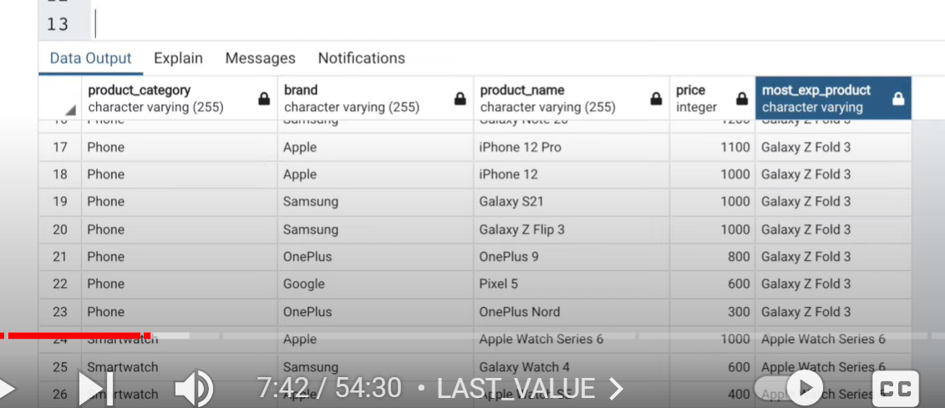

Select *,

LAST_VALUE(product_name) over (partition by product_category order by price desc range between unbounded preceding and unbounded following )

as least_exp_product

from product;

Explanation of Frame clause :

Unbounded preceeding and unbounded following is the frame clause we introduced here as we need to select the rows ranging from start to the last row in sql default frame clause is unbounded preceeding and current row) where current row will consider only till that row.

Now we see the difference between these two statements

Rows Unbounded preceeding and current row🡪It will select the exact current row

range between unbounded preceding and current row🡪 this will select the range of other rows having same/duplicate values like that particular row

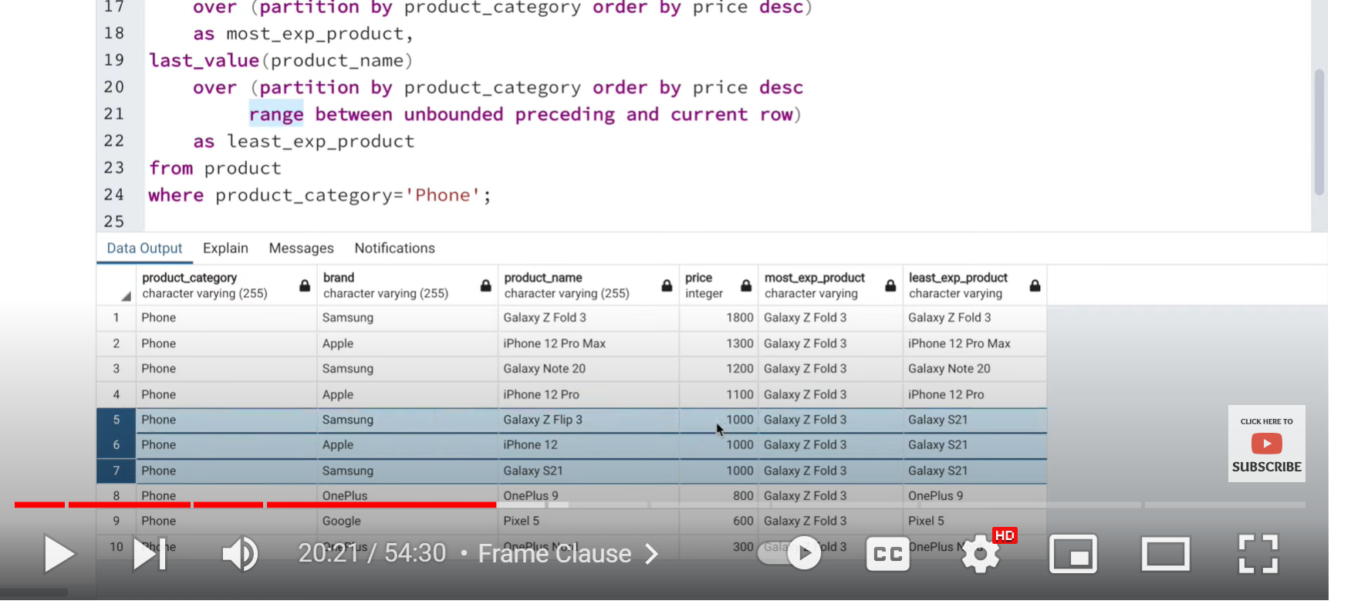

Instead of unbounding you can also pass number

range between 2preceding and 2 row it will select 2 rows and 2 rows after that particular row

Other way of writing windows query:

Window w as (partition by product category order by price desc

Range between 2 preceeding and 2 following

Select *

first_value(product_name)

over ( partition by product_category order by price desc )

as most_exp_product,

last_value(product_name)

over w

as least_exp_product

from product

where product_category = ‘phone’

NTH VALUE :

Write a query to display the second most expensive product under each category

Nth_value (product_name,2) over(partition by product_category order by price desc

Range between unbounded preceeding and unbounded following ) as second_most_exp

From product;

If no value is present satisfying the condition given in Nth_value it returns null value

NTILE :

Write a query to segregate all the expensive phones, mid-range phones and the cheaper phones

Select product_name ,

CASE when x.buckets = 1 then ‘Expensive Phones’

When x.buckets = 2 then ‘Mid Range Phones’

When x.buckets = 3 then ‘Cheap Phones’ END phone_category

From

(Select *

ntile(5) over (order by price desc) as buckets

from product

where product_category = ‘Phone’) X ;

CUME_DIST ; stands for Cummulative distribution

Helps to find distribution percentage of each record w.r.t to all the rows with in a result set .

Query : Fetch all the products which are constituting the first 30% of the data in products table based on price .

Select product_name, (cume_dist_percentage||’%’) as cume_dist_percentage from (

Select *,

Cume_dist() over (order by price desc) as cume_distribution,

round(cume_dist() over (order by price desc)::numeric * 100 , 2) as cume_dist_percentage

from product) X

where X.cume_dist_percentage <= 30;

PERCENT_RANK :

How percent rank is calculated internally below is the formula ;

Formula = Current Row No -1 / Total no of rows -1 */

Used to fetch relative rank for each row

Query : Query to identify how much percentage more expensive is “Galaxy Z Fold 3” when compared to all other products

Select product_name , per_rank

(Select *

Percent_rank() over(order by price) as percentage_rank,

round(percent_rank() over (order by price) ::numeric * 100, 2) as per_rank

From product) X;

Where X.product_name = ‘Galaxy Z Fold 3’;



COMMON TABLE EXPRESSIONS :

CTE , Sub-query Factoring or With Clause means the same.

Query : Fetch employees who earn more than average salary of all employees

Here actually we don’t need to use CTE but this is just an example

With average_salary (avg_sal) as

(select cast(avg(salary) as int) from employee)

Select * from employee e, average_salary av

Where e.salary > av.avg_sal;

Query2 ; Find stores whose sales where better than the average sales across all the stores

Here in the query it is mentioned as find stores whose sales (here sales referred to total sales of that store)

Average sales across all the stores means ( total sales of all the stores / 2)

Select s.store_id, sum(cost) as total_sales from sales from sales s group by store_id ;

For finding average sales across all the stores we can reuse the above query

Select cast(avg(total_sales) as int) as avg_sales_for_all_stores from

(Select s.store_id, sum(cost) as total_sales from sales from sales s group by s.store_id) X ;

Select * from

(Select s.store_id, sum(cost) as total_sales from sales from sales s group by store_id) total sales

join

Select cast(avg(total_sales) as int) as avg_sales_for_all_stores from

(Select s.store_id, sum(cost) as total_sales from sales from sales s group by s.store_id) X ) avg_sales

On total sales > avg_sales.avg_sales_for_all_stores;

**We will write the same above clause using CTE.**

**With Total_sales (store_id, total_sales_per_store)**

**(select s.store_id, sum(cost) as total_stores_per_store from sales s group by s.store_id),**

**Avg_sales (avg_sales_for_all_stores) as**

**(select cast(avg(total_sales_per_store) as int) as avg_sales_for_all_stores**

**From Total_Sales)**

**Select \***

**From Total_sales ts**

**Join avg_sales av**

**As ts.total_sales_per_store > av.avg_sales_for_all_stores**



**Solve the following query using CTE**

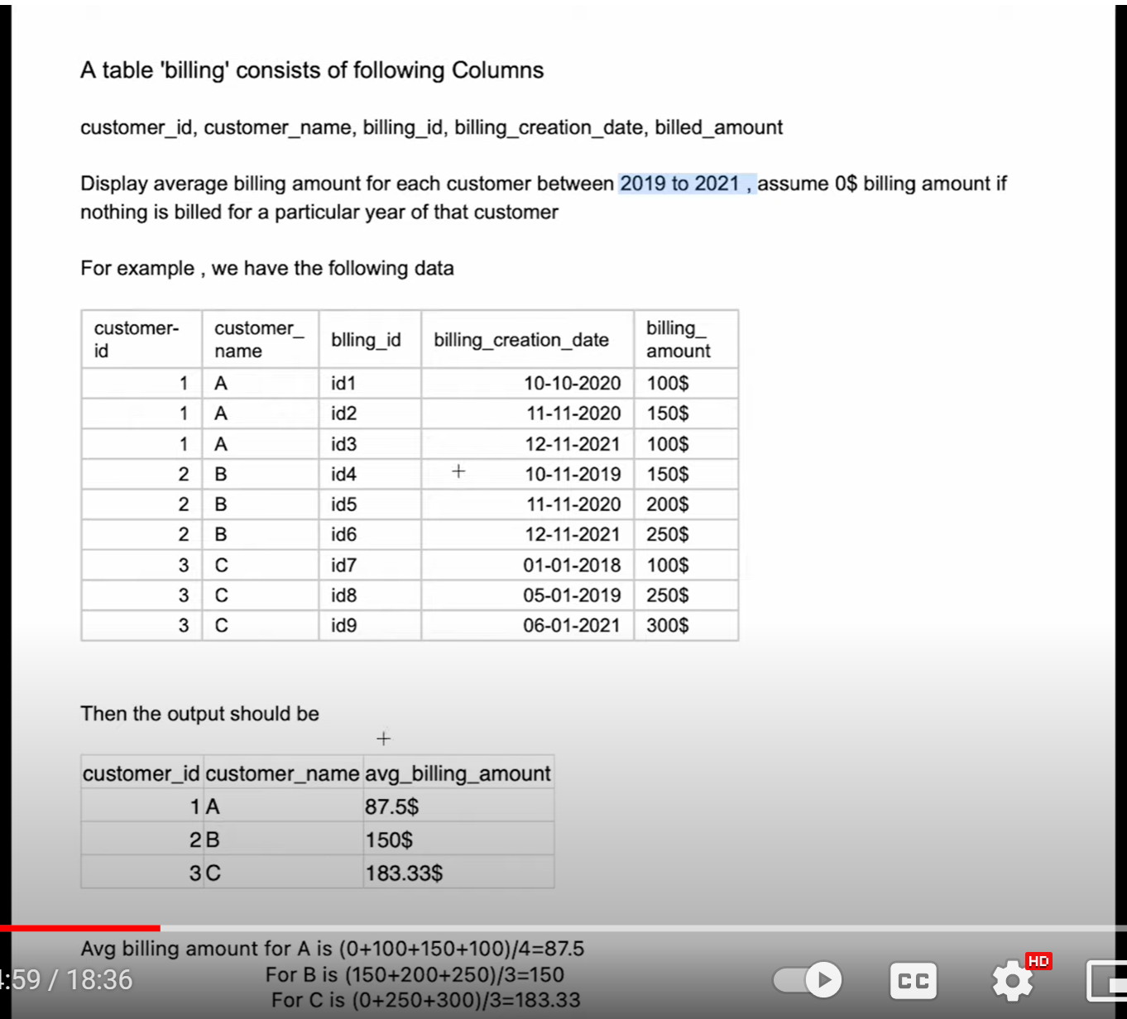

**Select customer_id,customer_name**

**group by customer_id,customer_name**

**Recursive SQL queries :**

**Basic Syntax :**

**WITH [RECURSIVE] CTE_name AS**

**(**

**SELECT query (Non Recursive query or the Base query)**

**UNION [ALL ]**

**SELECT query (Recursive query using CTE_name [with a termination condition])**

**)**

**SELECT * FROM CTE_name;**

**1.Now let’s write a recursive query using above syntax for printing numbers from 1 to 10**

**With recursive numbers as**

**(SELECT 1 as n (---------Base query----------)**

**Union**

**SELECT n+1 (Recursive query)**

**From numbers where n < 10)**

**Select * from numbers ;**

**Explanation : First time when we harcode the n value as 1 my number recursive function contains 1 when the recursive function executes it keeps on adding 1 here the numbers will be printed from 1 to 10 eventhough we gave the condition as n < 10 because when the code execution comes to the turn of 9 which is < 10 we print (9+1= 10) when execution comes to n as 10 10 < 10 it fails so it will not print 11.**

**Q2.Find the hierarchy of employees under given manager “ ASHA”**

**With recursive emp_hierarchy as**

**(select id,name,manager_id,designation, 1 as lvl**

**from emp_details where name = ‘Asha’**

**Union**

**Select E.id , E.name,E.manager_id, E.designation, H.lvl+1 as lvl**

**From emp_hierarchy H**

**Join emp_details E on H.id = E.manager_id**

**)**

**Select * from emp_hierarchy;**

**Look into this employee hierarchy fetching query again**

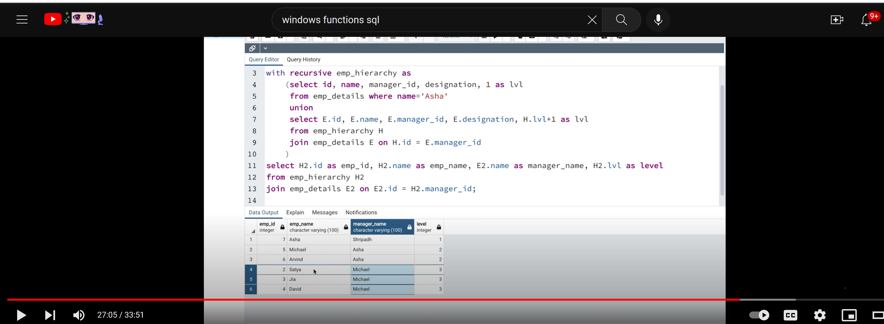

**3.Find the hierarchy of managers for a given employee**

**With recursive emp_hierarchy as**

**(select id,name,manager_id,designation, 1 as lvl**

**from emp_details where name = ‘David’**

**Union**

**Select E.id , E.name,E.manager_id, E.designation, H.lvl+1 as lvl**

**From emp_hierarchy H**

**Join emp_details E on H.manager_id= E.id**

**)**

**Select * from emp_hierarchy;**

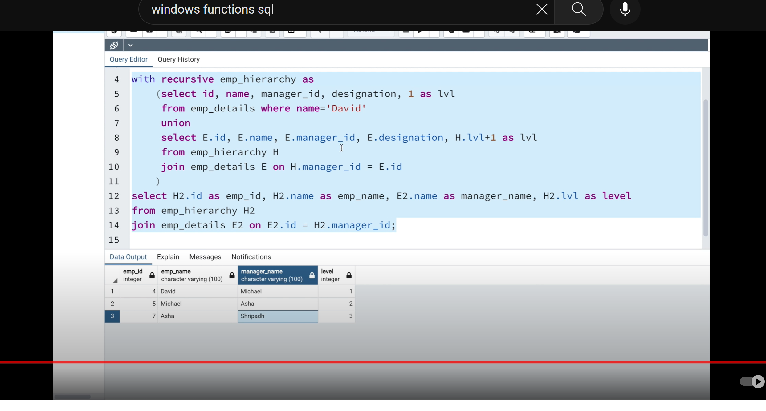



**JOINS : TRICKY QUESTIONS ON JOINS**

**INNER JOIN = COMMON RECORDS FROM BOTH TABLES**

**LEFT JOIN = COMMON RECORDS FROM BOTH TABLES(INNER JOIN) + ADDITIONAL RECORDS FROM LEFT TABLE**

**RIGHT JOIN = INNER JOIN + ADDITIONAL RECORDS FROM RIGHT TABLE**

**OUTER JOIN = INNER JOIN + ADDITIONAL RECORDS FROM LEFT TABLE WHICH ARE NOT PRESENT IN RIGHT TABLE + ADDITIONAL RECORDS FROM RIGHT TABLE WHICH ARE NOT PRESENT IN LEFT TABLE**

**CROSS JOIN : EVERY RECORD FROM LEFT WILL MATCH WITH EVERY RECORD FROM RIGHT TABLE**

**CROSS JOIN = CARTESIAN PRODUCT**

**NATURAL JOIN = THIS JOIN WORKS ON BASIS OF MAPPING COLUMN NAMES IF TWO TABLES HAVE THE SAME COLUMN NAME IT WILL MAKE INNER JOIN ON THAT COLUMN AND FETCH RECORDS.**

**FOR CROSS JOIN AND NATURAL JOIN WE DON’T NEED JOIN CONDITION.**



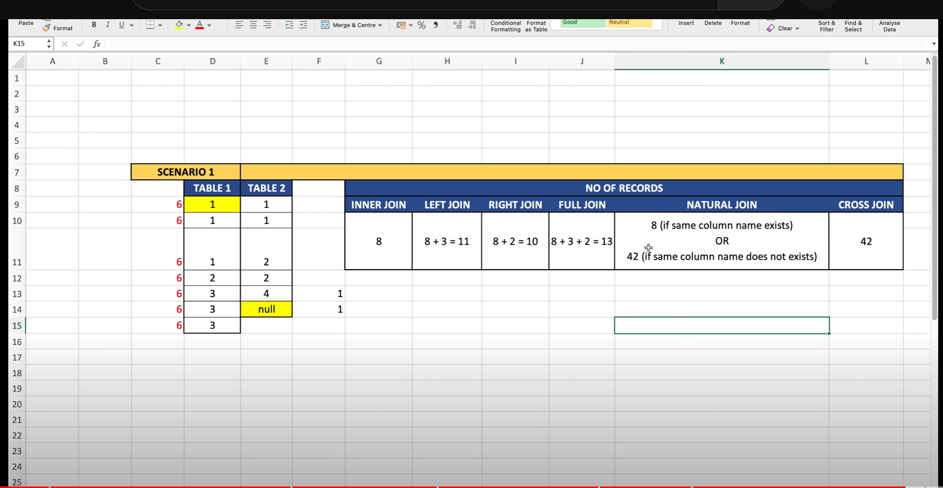

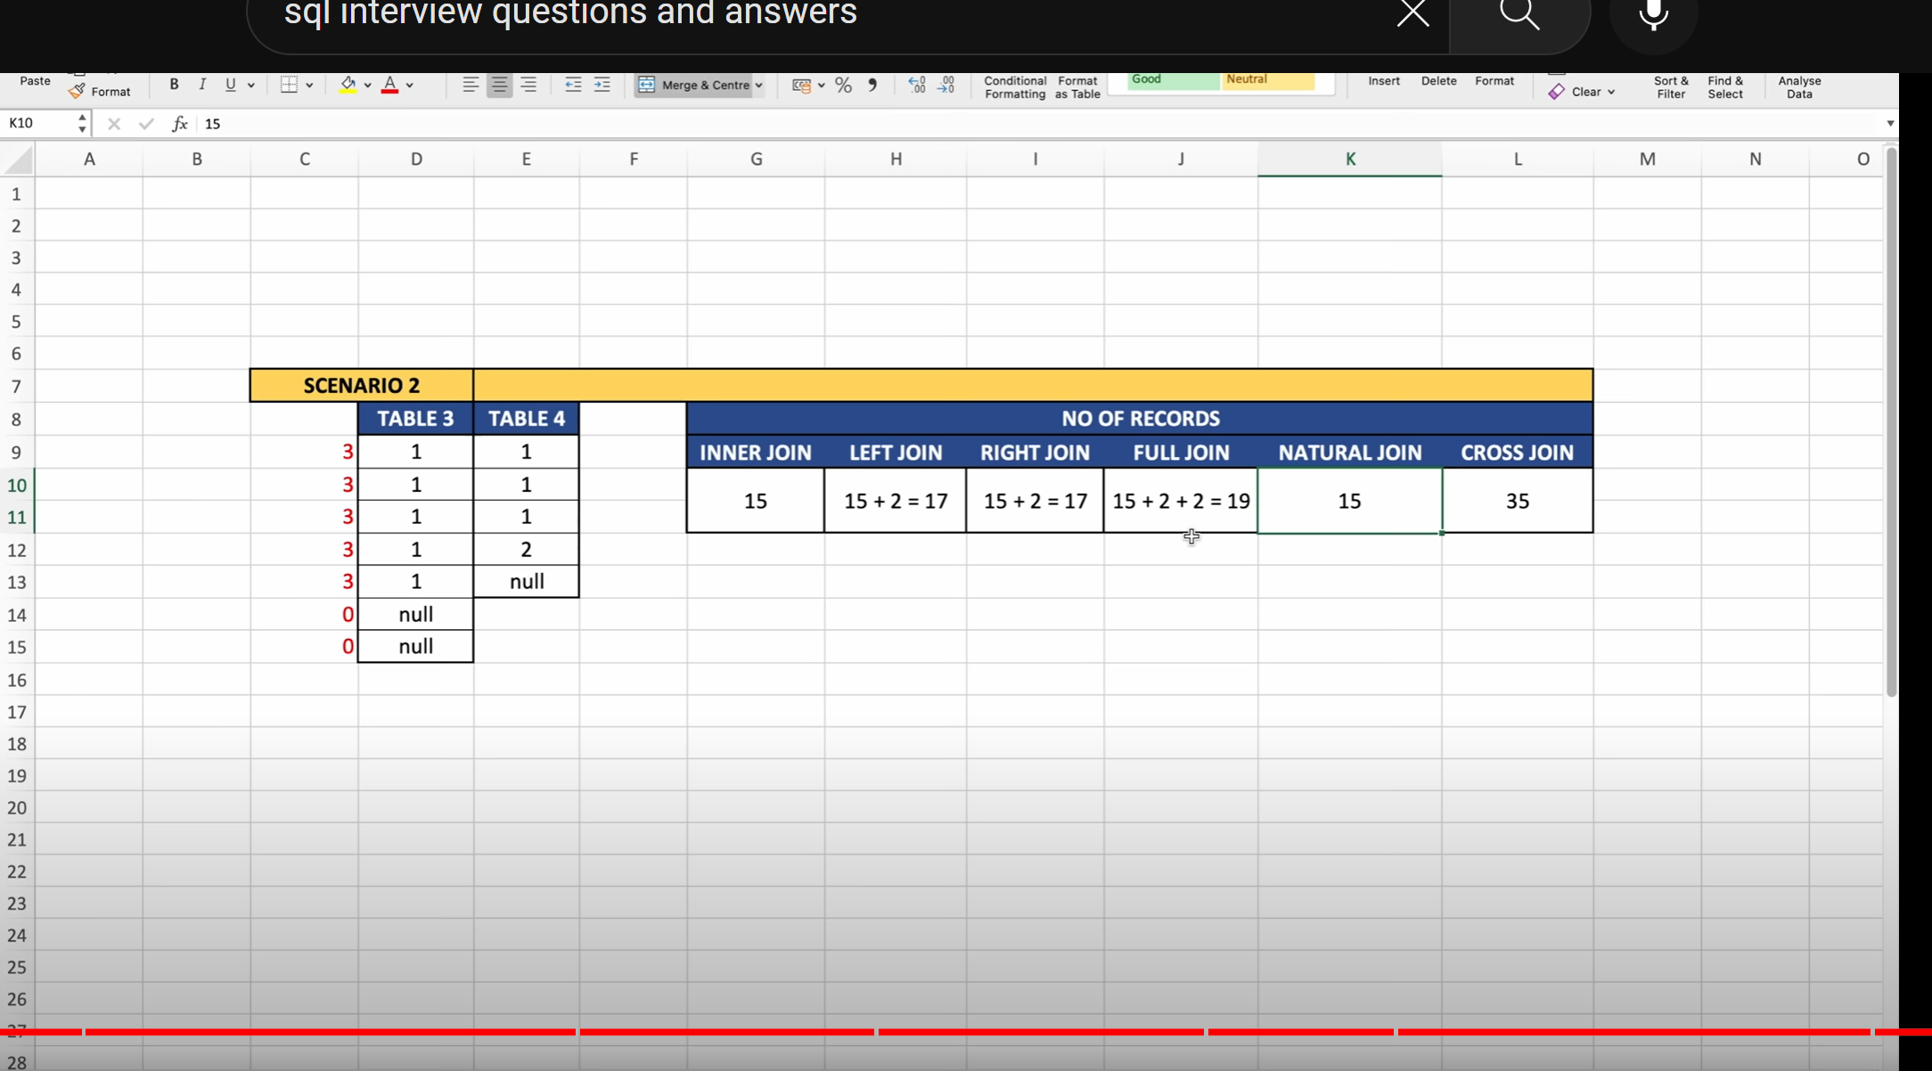

**Views :**



**Materialized views :**

**Materialized view is a database object created by sql query similar to a view**

**1.It stores the SQL query**

**2.Stores the data returned from sql query**

**3.Materialized view improves the performance of query**

**e.g: select id,avg(val),count(*)**

**from random_tab**

**group by id;(Normal query)**

**create materialized view mv_random_tab as**

**select id,avg(val),count(*) from random_tab**

**group by id;**

**select * from mv_random_tab;(this fetches the results in very less time compared to the above normal query so materialized views are responsible for performance tuning).If you make delete or insert data from the table it doesn’t affect materialized view until we refresh the materialized view**

**query to refresh materialized view : refresh materialized view mv_random_tab;**

**question ? When to use materialized view ?**

**its of no use of creating materialized view for each and every query takes time, we need to create a materialized view when we think that there is no frequent changes to the base table like in some projects we upload the data into the table on monthly basis , biweekly basis and we are generating reports for stake holders by using data from table where stake holders refresh the reports on daily basis .In this scenario if we don’t create materialize view for such huge data whenever these people refresh reports its going to take lot of time.**

**Diff between materialized view and view :**

**Materialized view stores both query and data and normal view stores only query(whenever u execute view it internally executes the query ) materialized views are more faster than views because it wont execute the query it just returns the data which is already stored.**

**select * from mv_random_tab;**